2.6

Code

>> tv = imread('tv.jpg');

>> F = fft2(tv);

>> S = abs(F);

>> imagesc(fftshift(S.^0.1));

>> colormap('default');

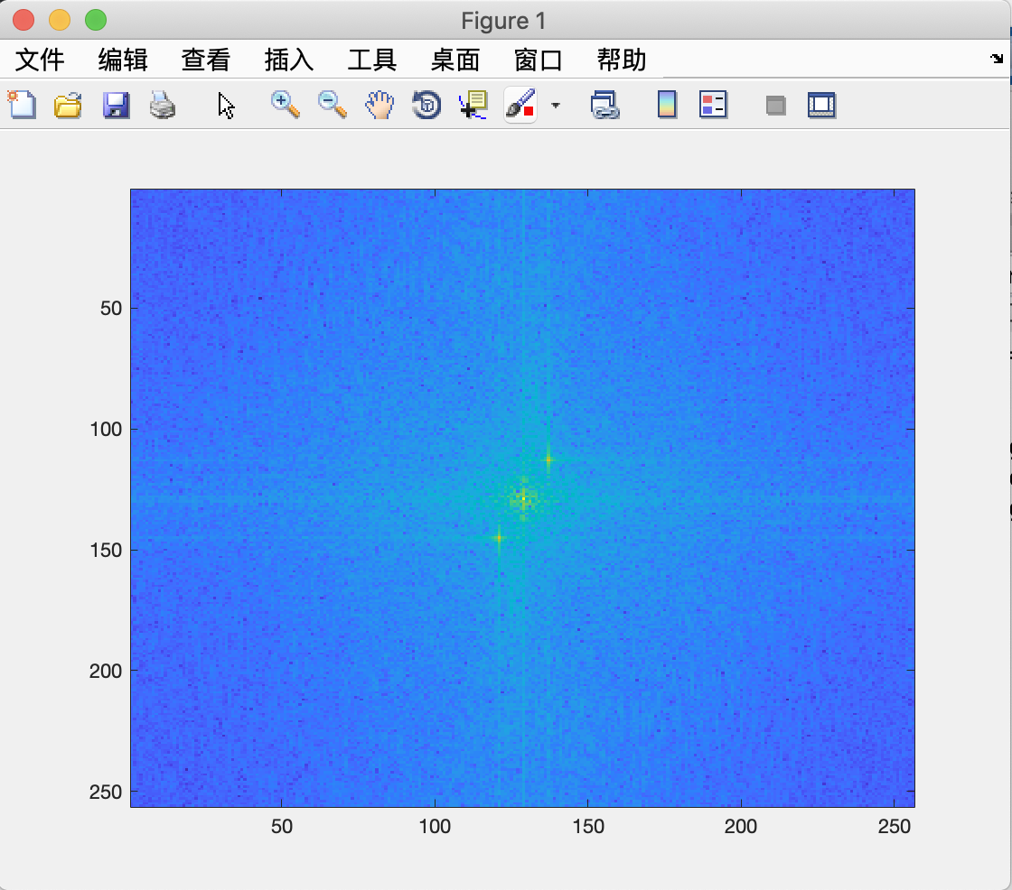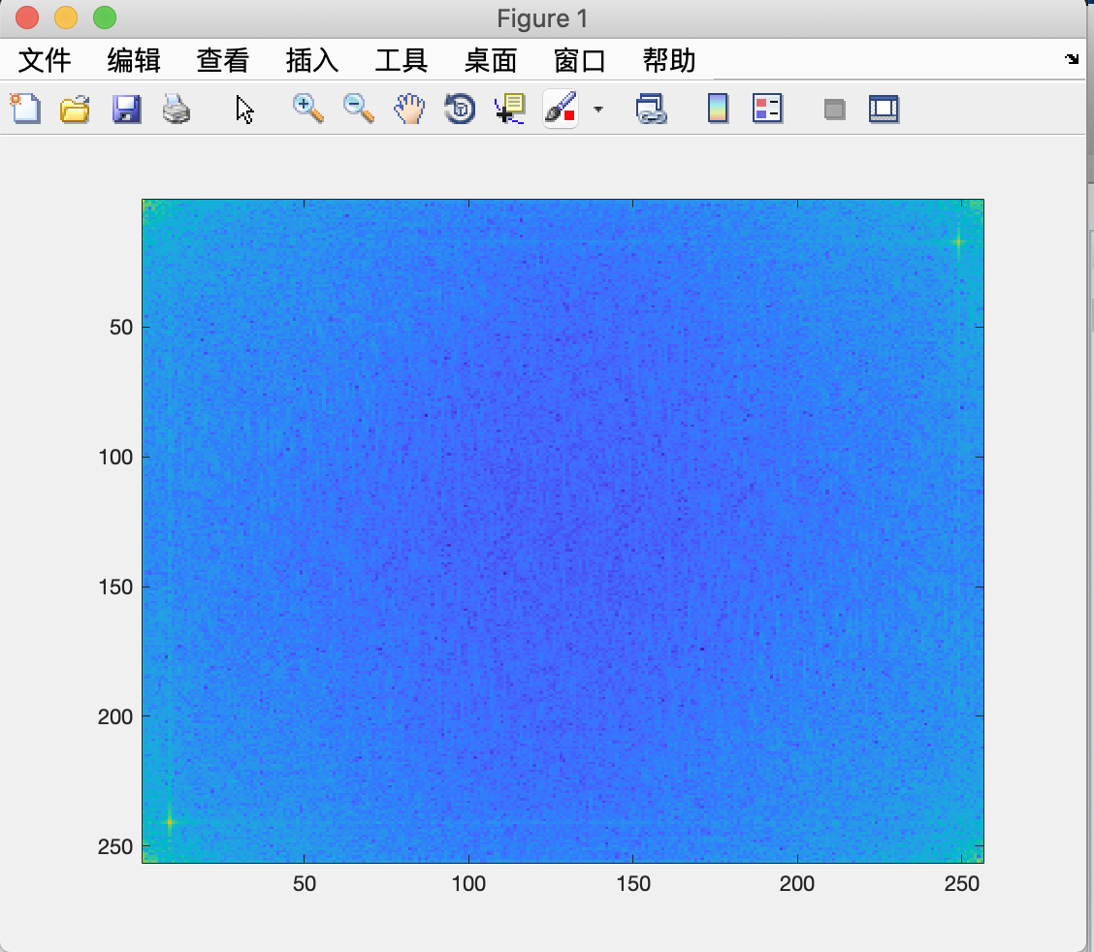

The actual peak (1.1) （9.241）（249.17） （255，256）

>>F(15:19, 247:251) = 0;

>> F(1:3,1:3)=0;

>> F(239:243,7:11)=0;

>>F(254:256,253:256)=0;

>>TV2=ifft2(F);

>>TV2=real(TV2);

>>TV2=TV2+130;

>>TV2=uint8(TV2);

>>imshow(TV2)

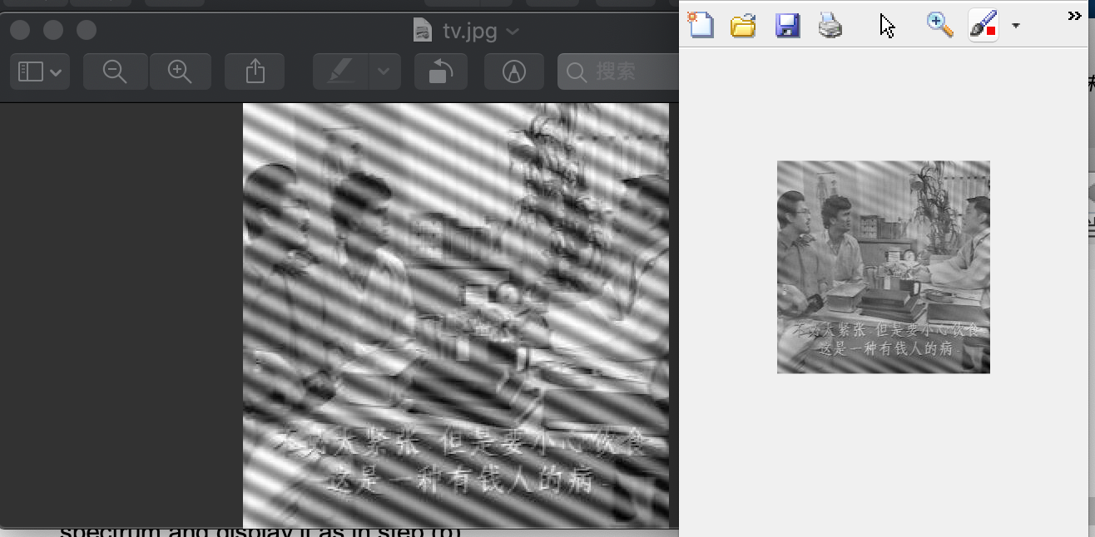

I think we can reprocess this image in the spatial domain again,

So the monkey need to turn into gray picture. It was a rgb picture.

>> whos mon

Name Size Bytes Class Attributes

mon 256x256x3 196608 uint8

>> mon = rgb2gray(mon);

F = fft2(mon);

>> S =abs(F);

